#include<stdio.h>

#include<conio.h>

#include<dos.h>

#include<graphics.h>

#include<stdlib.h>

#include<time.h>

int main()

{

int gd=DETECT,gm;

clrscr();

initgraph(&gd,&gm,"C:\\TC\\BGI");

arduino_on();

arduino_body();

arduino_connect();

getch();

cleardevice();

return 0;

}

arduino_on()

{

char a;

printf("Press any key and tap enter twice to switch on Arduino\n");

scanf("%c",&a);

getch();

cleardevice();

return 0;

}

arduino_body()

{

line(30,40,613,40);

line(30,40,30,100);

line(613,40,613,120);

line(613,120,630,145);

line(630,145,630,370);

line(30,400,600,400);

line(600,400,600,380);

line(600,380,630,370);

line(30,140,30,400);

circle(615,160,8);

rectangle(580,185,605,245);

rectangle(585,195,590,200);

rectangle(595,195,600,200);

rectangle(585,210,590,215);

rectangle(595,210,600,215);

rectangle(585,225,590,230);

rectangle(595,225,600,230);

rectangle(560,200,570,230);

line(560,210,570,210);

line(560,206,570,206);

line(560,216,570,216);

line(560,225,570,225);

rectangle(270,280,570,320);

rectangle(280,275,290,280);

rectangle(300,275,310,280);

rectangle(320,275,330,280);

rectangle(340,275,350,280);

rectangle(360,275,370,280);

rectangle(380,275,390,280);

rectangle(400,275,410,280);

rectangle(420,275,430,280);

rectangle(440,275,450,280);

rectangle(460,275,470,280);

rectangle(480,275,490,280);

rectangle(500,275,510,280);

rectangle(520,275,530,280);

rectangle(540,275,550,280);

rectangle(370,240,390,250);

rectangle(370,255,390,263);

rectangle(170,375,210,390);

line(180,375,180,390);

line(200,375,200,390);

rectangle(280,320,290,325);

rectangle(300,320,310,325);

rectangle(320,320,330,325);

rectangle(340,320,350,325);

rectangle(360,320,370,325);

rectangle(380,320,390,325);

rectangle(400,320,410,325);

rectangle(420,320,430,325);

rectangle(440,320,450,325);

rectangle(460,320,470,325);

rectangle(480,320,490,325);

rectangle(500,320,510,325);

rectangle(520,320,530,325);

rectangle(540,320,550,325);

rectangle(390,330,410,338);

line(310,340,420,340);

rectangle(215,375,455,390);

rectangle(465,375,585,390);

line(275,375,275,390);

line(305,375,305,390);

line(340,375,340,390);

line(365,375,365,390);

line(395,375,395,390);

line(425,375,425,390);

line(230,375,230,390);

line(485,375,485,390);

line(505,375,505,390);

line(525,375,525,390);

line(545,375,545,390);

line(565,375,565,390);

line(470,340,580,340);

rectangle(150,180,160,185);

rectangle(165,180,175,185);

rectangle(180,180,190,185);

line(150,195,190,195);

arc(190,205,-90,90,10);

arc(150,205,-270,270,10);

line(150,215,190,215);

rectangle(160,225,180,240);

rectangle(165,280,170,300);

rectangle(190,280,200,300);

rectangle(220,280,225,300);

rectangle(110,70,120,100);

line(110,80,120,80);

line(110,90,120,90);

rectangle(105,110,125,115);

rectangle(105,130,125,135);

rectangle(105,145,125,165);

rectangle(105,175,125,180);

rectangle(135,180,145,185);

rectangle(40,180,80,250);

line(40,200,80,200);

line(40,230,80,230);

rectangle(90,220,100,240);

rectangle(90,260,120,300);

rectangle(120,265,130,270);

rectangle(120,275,130,280);

rectangle(120,285,130,290);

rectangle(70,270,90,290);

rectangle(20,330,30,380);

rectangle(30,335,80,377);

line(390,282,415,282);

line(380,293,415,293);

rectangle(60,60,90,90);

rectangle(50,66,60,69);

rectangle(90,66,100,69);

rectangle(50,74,60,77);

rectangle(50,83,60,86);

rectangle(90,83,100,86);

circle(610,350,8);

circle(75,75,8);

circle(130,60,6);

rectangle(130,70,190,95);

rectangle(145,75,150,80);

rectangle(160,75,165,80);

rectangle(175,75,180,80);

rectangle(145,85,150,90);

rectangle(160,85,165,90);

rectangle(175,85,180,90);

line(160,100,180,100);

arc(180,105,-90,90,5);

arc(160,105,-270,270,5);

line(160,110,180,110);

circle(175,105,2);

circle(165,105,2);

line(160,115,180,115);

arc(180,120,-90,90,5);

arc(160,120,-270,270,5);

line(160,125,180,125);

circle(175,120,2);

circle(165,120,2);

rectangle(160,140,180,160);

rectangle(80,90,90,95);

rectangle(10,100,90,140);

line(70,100,70,140);

arc(50,100,0,180,8);

arc(50,140,180,360,8);

rectangle(140,55,440,65);

rectangle(443,55,603,65);

line(170,55,170,65);

line(200,55,200,65);

line(230,55,230,65);

line(260,55,260,65);

line(290,55,290,65);

line(320,55,320,65);

line(350,55,350,65);

line(380,55,380,65);

line(410,55,410,65);

line(463,55,463,65);

line(483,55,483,65);

line(503,55,503,65);

line(523,55,523,65);

line(543,55,543,65);

line(563,55,563,65);

line(583,55,583,65);

rectangle(245,90,270,100);

line(260,110,600,110);

rectangle(245,120,270,130);

rectangle(250,132,265,152);

rectangle(245,155,270,165);

outtextxy(220,158,"TX");

rectangle(245,168,270,178);

rectangle(245,200,270,210);

rectangle(245,215,270,225);

rectangle(245,230,270,245);

rectangle(250,250,266,270);

circle(140,380,8);

circle(210,350,20);

circle(160,350,20);

circle(235,110,2);

circle(235,135,2);

circle(280,130,2);

circle(280,170,2);

outtextxy(233,122,"L");

line(440,130,480,130);

line(440,150,480,150);

arc(480,140,-90,90,10);

arc(440,140,-270,270,10);

rectangle(495,150,515,160);

rectangle(498,162,510,182);

line(498,167,510,167);

line(498,172,510,172);

line(498,177,510,177);

setfillstyle(SOLID_FILL,BLUE);

floodfill(300,350,WHITE);

floodfill(445,140,WHITE);

floodfill(170,119,WHITE);

floodfill(170,105,WHITE);

setfillstyle(SOLID_FILL,WHITE);

floodfill(405,322,WHITE);

floodfill(285,322,WHITE);

floodfill(305,322,WHITE);

floodfill(325,322,WHITE);

floodfill(345,322,WHITE);

floodfill(365,322,WHITE);

floodfill(385,322,WHITE);

floodfill(425,322,WHITE);

floodfill(445,322,WHITE);

floodfill(465,322,WHITE);

floodfill(485,322,WHITE);

floodfill(505,322,WHITE);

floodfill(525,322,WHITE);

floodfill(545,322,WHITE);

floodfill(405,278,WHITE);

floodfill(285,278,WHITE);

floodfill(305,278,WHITE);

floodfill(325,278,WHITE);

floodfill(345,278,WHITE);

floodfill(365,278,WHITE);

floodfill(385,278,WHITE);

floodfill(425,278,WHITE);

floodfill(445,278,WHITE);

floodfill(465,278,WHITE);

floodfill(485,278,WHITE);

floodfill(505,278,WHITE);

floodfill(525,278,WHITE);

floodfill(545,278,WHITE);

floodfill(500,165,WHITE);

floodfill(500,179,WHITE);

setfillstyle(SOLID_FILL,YELLOW);

floodfill(45,195,WHITE);

floodfill(45,240,WHITE);

setfillstyle(SOLID_FILL,-8);

floodfill(205,340,WHITE);

floodfill(148,205,WHITE);

floodfill(150,340,WHITE);

setfillstyle(SOLID_FILL,-9);

floodfill(380,245,WHITE);

floodfill(380,260,WHITE);

floodfill(130,90,WHITE);

floodfill(250,95,WHITE);

floodfill(115,132,WHITE);

floodfill(115,112,WHITE);

floodfill(115,155,WHITE);

floodfill(115,178,WHITE);

floodfill(140,183,WHITE);

floodfill(155,183,WHITE);

floodfill(170,183,WHITE);

floodfill(185,183,WHITE);

floodfill(250,205,WHITE);

floodfill(95,230,WHITE);

floodfill(250,220,WHITE);

floodfill(250,240,WHITE);

floodfill(255,260,WHITE);

floodfill(175,380,WHITE);

floodfill(85,280,WHITE);

floodfill(205,380,WHITE);

floodfill(598,198,WHITE);

floodfill(598,213,WHITE);

floodfill(598,228,WHITE);

floodfill(588,198,WHITE);

floodfill(588,213,WHITE);

floodfill(588,228,WHITE);

floodfill(510,153,WHITE);

floodfill(45,144,WHITE);

floodfill(45,98,WHITE);

floodfill(253,122,WHITE);

floodfill(253,135,WHITE);

floodfill(250,173,WHITE);

floodfill(250,163,WHITE);

floodfill(148,78,WHITE);

floodfill(163,78,WHITE);

floodfill(178,78,WHITE);

floodfill(148,88,WHITE);

floodfill(163,88,WHITE);

floodfill(178,88,WHITE);

floodfill(85,85,WHITE);

floodfill(400,335,WHITE);

floodfill(45,120,WHITE);

floodfill(75,120,WHITE);

setfillstyle(SOLID_FILL,12);

floodfill(80,80,WHITE);

outtextxy(300,200,"A r d u i n o");

outtextxy(440,100,"DIGITAL (PWM~) TX RX");

outtextxy(518,153,"ON");

outtextxy(442,138,"U N O");

outtextxy(220,171,"RX");

outtextxy(200,70,"AREF");

outtextxy(235,70,"GND");

outtextxy(270,70,"13");

outtextxy(300,70,"12");

outtextxy(330,70,"11");

outtextxy(360,70,"10");

outtextxy(390,70,"9");

outtextxy(420,70,"8");

outtextxy(450,70,"7");

outtextxy(470,70,"6");

outtextxy(490,70,"5");

outtextxy(510,70,"4");

outtextxy(530,70,"3");

outtextxy(550,70,"2");

outtextxy(570,70,"1");

outtextxy(590,70,"0");

outtextxy(578,175,"ICSP");

outtextxy(380,285,"ATMEL 35473D");

outtextxy(350,295,"A T M E G A 3 2 8 P U");

outtextxy(380,305,"1 7 4 P C 5");

outtextxy(380,345,"POWER");

outtextxy(500,345,"ANALOG IN");

outtextxy(235,365,"IOREF");

outtextxy(280,365,"RST");

outtextxy(310,365,"3.3V");

outtextxy(350,365,"5V");

outtextxy(370,365,"GND");

outtextxy(400,365,"GND");

outtextxy(430,365,"V1n");

outtextxy(470,365,"A0");

outtextxy(490,365,"A1");

outtextxy(510,365,"A2");

outtextxy(530,365,"A3");

outtextxy(550,365,"A4");

outtextxy(570,365,"A5");

outtextxy(184,380,"M7");

outtextxy(155,335,"CK");

outtextxy(155,345,"47");

outtextxy(150,355,"25V");

outtextxy(205,335,"CK");

outtextxy(205,345,"47");

outtextxy(200,355,"25V");

outtextxy(130,118,"JP2");

outtextxy(158,132,"|||");

outtextxy(158,162,"|||");

outtextxy(155,140,"-");

outtextxy(155,145,"-");

outtextxy(155,150,"-");

outtextxy(155,155,"-");

outtextxy(180,140,"-");

outtextxy(180,145,"-");

outtextxy(180,150,"-");

outtextxy(180,155,"-");

outtextxy(155,225,"-");

outtextxy(155,230,"-");

outtextxy(155,235,"-");

outtextxy(180,225,"-");

outtextxy(180,230,"-");

outtextxy(180,235,"-");

outtextxy(185,280,"-");

outtextxy(185,285,"-");

outtextxy(185,290,"-");

outtextxy(185,295,"-");

outtextxy(146,203,"16.000");

outtextxy(45,210,"507H");

outtextxy(100,220,"-");

outtextxy(100,225,"-");

outtextxy(100,235,"-");

outtextxy(100,230,"-");

getch();

cleardevice();

return 0;

}

arduino_connect()

{

int e,option;

char s[100],S[100],i,max=40,min=15;

printf("1.LM35 Temperature Sensor\n2.LCD");

printf("\n\nChoose your option\n");

scanf("%d",&option);

printf("\n\nPress any key to connect the wires\n");

switch(option)

{

case 1:

getch();

cleardevice();

setcolor(03); //blue wire connected to PC

line(0,120,20,120);

line(0,121,20,121);

line(0,122,20,122);

line(0,123,20,123);

line(0,124,20,124);

line(0,124,0,0);

line(1,124,1,0);

line(2,124,2,0);

line(3,124,3,0);

setcolor(WHITE);

outtextxy(10,10,"PC");

setcolor(RED); //red wire connected to A0

line(475,370,475,450);

line(476,370,476,450);

line(477,370,477,450);

line(475,450,570,450);

line(475,451,570,451);

line(475,452,570,452);

setcolor(GREEN); //green wire connected to GND

line(410,370,410,460);

line(411,370,411,460);

line(412,370,412,460);

line(410,460,570,460);

line(410,461,570,461);

line(410,462,570,462);

setcolor(YELLOW); //yellow wire connected to 5V

line(355,370,355,440);

line(356,370,356,440);

line(357,370,357,440);

line(355,440,570,440);

line(355,441,570,441);

line(355,442,570,442);

setcolor(WHITE); //LM35 Temperature Sensor

line(580,430,580,470);

line(580,430,590,430);

line(580,470,590,470);

arc(590,450,-90,90,20);

outtextxy(585,440,"LM");

outtextxy(585,450,"35");

setcolor(WHITE); //LM35 three terminals

line(570,450,580,450);

line(570,451,580,451);

line(570,452,580,452);

line(570,440,580,440);

line(570,441,580,441);

line(570,442,580,442);

line(570,460,580,460);

line(570,461,580,461);

line(570,462,580,462);

setcolor(WHITE);

arduino_body();

cleardevice();

for(i=0;i<1;i++)

{

int e=(rand()+min)%(max+1);

setcolor(GREEN);

setcolor(GREEN);

sprintf(S,"%d C",e);

outtextxy(240,230,S);

rectangle(200,220,300,250);

setcolor(WHITE);

outtextxy(130,200,"Room temperature on LED Screen is");

}

break;

case 2:

getch();

cleardevice();

rectangle(100,0,600,30);

setcolor(03); //blue wire connected to PC

line(0,120,20,120);

line(0,121,20,121);

line(0,122,20,122);

line(0,123,20,123);

line(0,124,20,124);

line(0,124,0,0);

line(1,124,1,0);

line(2,124,2,0);

line(3,124,3,0);

setcolor(WHITE);

outtextxy(10,10,"PC");

setcolor(RED); //red wire connected to 5V

line(355,370,355,440);

line(356,370,356,440);

line(357,370,357,440);

line(355,440,620,440);

line(355,441,621,441);

line(355,442,622,442);

line(620,440,620,39);

line(621,441,621,38);

line(622,442,622,37);

line(620,39,180,39);

line(621,38,180,38);

line(622,37,180,37);

line(180,39,180,30);

line(181,40,181,30);

line(182,41,182,30);

setcolor(GREEN); //green wire connected to GND

line(375,370,375,430);

line(376,370,376,430);

line(377,370,377,430);

line(377,430,615,430);

line(376,431,615,431);

line(375,432,615,432);

line(615,430,615,36);

line(616,431,616,35);

line(617,432,617,34);

line(615,36,220,36);

line(616,35,220,35);

line(617,34,220,34);

line(220,36,220,30);

line(221,35,221,30);

line(222,34,222,30);

setcolor(YELLOW); //yellow wire connected to 5

line(490,65,490,30);

line(491,65,491,30);

line(492,65,492,30);

setcolor(12); //orange wire connected to 4

line(510,65,510,30);

line(511,65,511,30);

line(512,65,512,30);

setcolor(BROWN); //brown wire connected to 3

line(530,65,530,30);

line(531,65,531,30);

line(532,65,532,30);

setcolor(10); //light green wire connected to 2

line(550,65,550,30);

line(551,65,551,30);

line(552,65,552,30);

setcolor(07); //grey wire connected to 12

line(300,65,300,30);

line(301,65,301,30);

line(302,65,302,30);

setcolor(05); //pink wire connected to 11

line(330,65,330,30);

line(331,65,331,30);

line(332,65,332,30);

setcolor(WHITE);

outtextxy(545,20,"D7");

outtextxy(525,20,"D6");

outtextxy(505,20,"D5");

outtextxy(485,20,"D4");

outtextxy(465,20,"D3");

outtextxy(445,20,"D2");

outtextxy(425,20,"D1");

outtextxy(405,20,"D0");

outtextxy(330,20,"E");

outtextxy(310,20,"RW");

outtextxy(290,20,"RS");

outtextxy(210,20,"VDD VEE");

outtextxy(170,20,"VSS");

setcolor(GREEN);

outtextxy(110,10,"LCD");

setcolor(WHITE);

arduino_body();

cleardevice();

printf("Enter text code in Arduino\n");

scanf("%s",s);

setcolor(GREEN);

rectangle(80,220,250,250);

outtextxy(150,230,s);

break;

}

getch();

return 0;

}

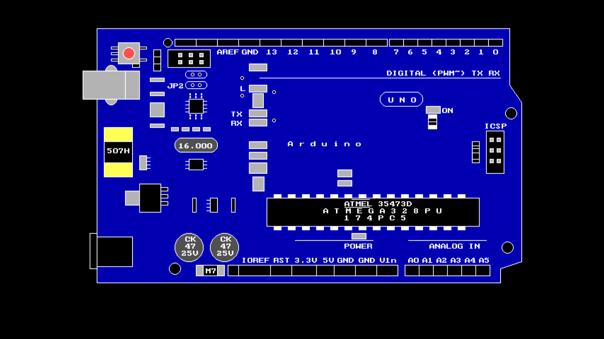

**ARDUINO BOARD (UNCONNECTED)**

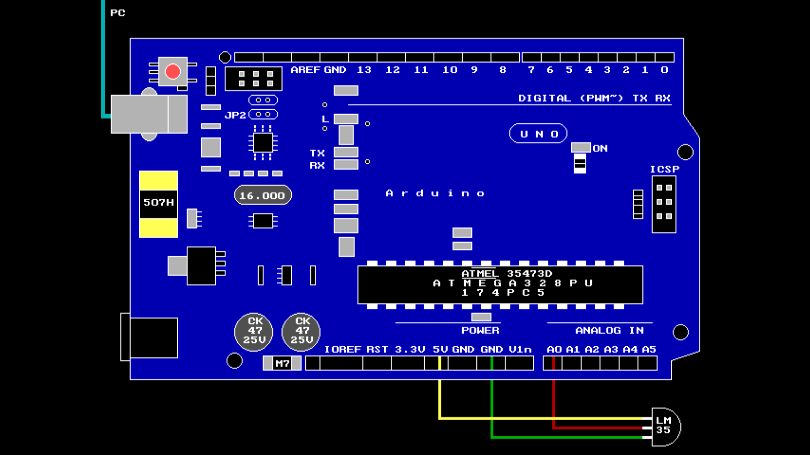

**CONNECTIONS FOR LM35 TEMPERATURE SENSOR**

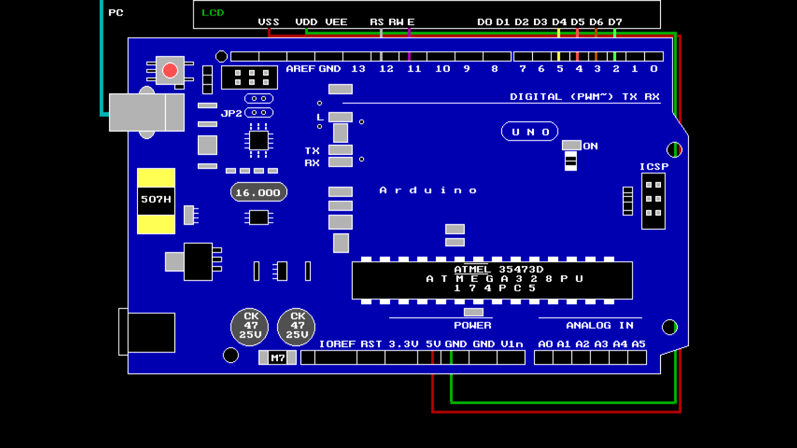

**CONNECTIONS FOR LCD**

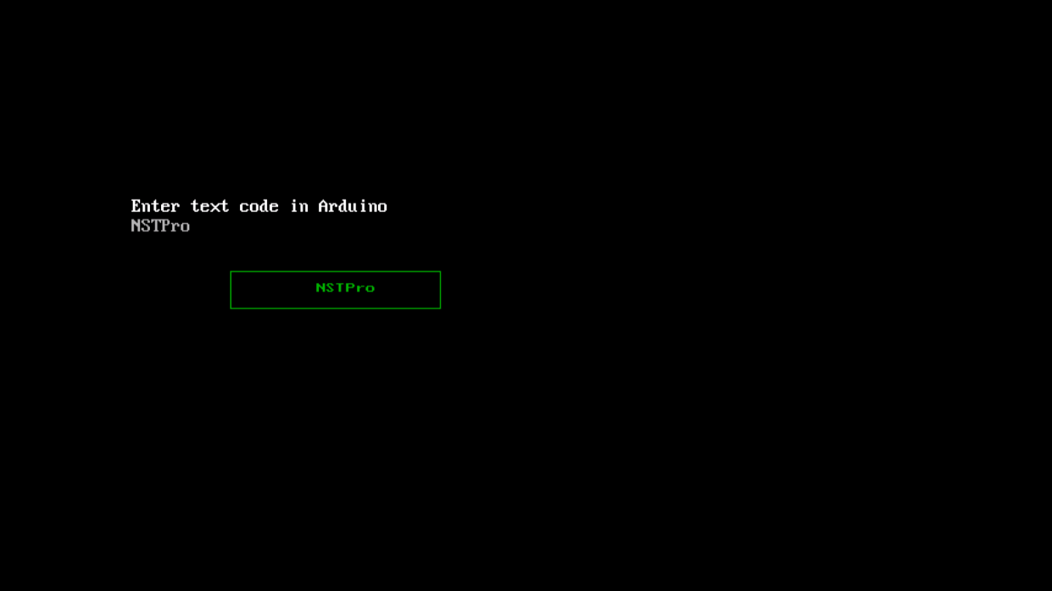

**OUTPUT ON LCD SCREEN**